**Incedo KYC Blockchain**

*Proprietary & Confidential*

**Table of Contents**

1 ABSTRACT 3

2 sOLUTION APPROACH 4

3 dESIGN aRCHITECTURE 5

4 **BUSINESS IMPACT 6**

**Incedo KYC Blockchain**

Know your customer (KYC) checks are currently an extremely time consuming and costly affair. Banks have to spend Millions of Rupees every year to keep up with KYC regulations or risk being fined heavily. Whenever a customer creates an account in any bank(s), He/she has to provide his/her details repeatedly. This is a waste of time and efforts. To avoid this hustle, a decentralized KYC registry is introduced, which is known as Blockchain.

The nature of a block-chain ensures that unauthorized changes to the data are automatically invalidated. This decentralized P2P network, consisting of a common KYC registry, where customer creates one time KYC profile which is cryptographically secured. Once the customer approves the request of accessing the profile details to the bank, the bank can view the already updated details of the customers on their site.

Since KYC is for a life time, there is a facility of updating any details in the KYC at any point of time, only on the approval of the customer. Any bank can update the KYC details of the customer only when the customer approves it.

**Solution Approach**

**Blockchain Portal:**

* Portal will be created where any user can keep his or her documents in the desired format (from the available formats: PDF, Image, etc.
* Every user will be provided with a particular cloud space.
* User can join whenever desired, at the time of joining a dedicated, personal and confidential account will be created for the user.
* User will save the desired and required information on the portal.

**Portal accessibility:**

* User will have all the rights from deletion to editing.
* User will have to follow the login policy, hence will have to provide the login credentials while logging in which will be validated with the backend data and if found legit shall allow the user to access the portal
* User will have rights to assign any institute for access or editing rights.
* Once the rights are assigned to the institute, the institute can receive the required information and/or documents as soft copy from the portal.
* In case user plans to delete the account no data shall be retained with the portal.
* If any user wants to update his details on the portal, …
* If any bank wants to edit the details of the portal, the new block would be created in that case and then updated which would be after the approval of the customer’s consent.

**Portal Features:-**

* Immutable
* Better encryption and security
* Single version of truth
* Cost and Time Effective

**Design Architecture**

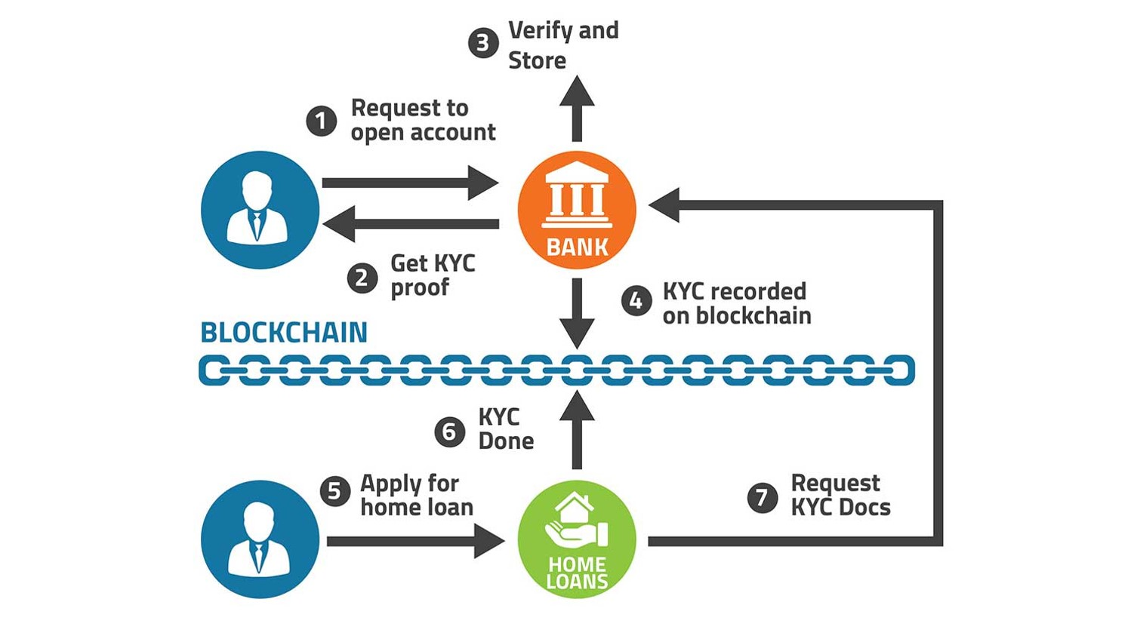

**Business Impact**

This process will completely change the manual KYC verification process which will reduce the cost of manual work done to complete the KYC verification. Banks have to spend millions of dollars every year to keep up with KYC regulations or risk being fined heavily. Through KYC chain we aim to simplify this process to a great extent.

Nowadays, an ever increasing client base, it is very hard to maintain all banking processes which also includes KYC verification and up to $1 billion dollars are spent annually by bank on KYC checks in U.S . According to the latest survey, 89% customers had a bad KYC experience. There is a need to introduce a decentralized and distributed system which will reduce the cost, time and human resource.